Name:________________

1.3 Right Triangle Applications

**Solve each triangle (find all missing sides and missing angles). Round side measures to the nearest thousandth and angle measures to the nearest degree.**

**A**

**B**

**C**

**a**

**b**

**c**

1. 

2.  3. 

**Draw a picture and solve the problem. Round all side measures to three decimal places and all angles measures to the nearest degree**

4. A 24 foot ladder leaning against a wall makes a  angle with the ground.

a. How high up the wall does the ladder reach?

b. How far is the base of the ladder from the wall?

5. A plane passes directly over your head an altitude of 500 feet. Two seconds later you observe that its angle of elevation is 

a.) How far did the plane travel during those two seconds.

b.) How fast is the plane traveling in **miles per hour**?

6. From a window 35 meters high, the angle of depression to the top of a nearby streetlight is . The angle of depression to the base of the streetlight is . How tall is the streetlight?

**Draw a diagram and solve each problem. Round all side measures to three decimal places and all angle measures to the nearest degree.**

7. Your cat Fuzzy is trapped in tree 8.2 meters above the ground. Your ladder is only 8.7 meters long. If you place the ladder’s tip right next to Fuzzy, what angle will the ladder make with the ground?

8. A rocket shoots straight up from a launch pad. Five seconds after lift-off, Billy, who is standing 2 miles away, notes that the rocket’s angle of elevation is . Four seconds after that, the angle of elevation is . How far did the rocket rise during those four seconds?

9. A man in a forest stands 20 feet from a huge pine tree. The angle of elevation from eye level to the top of the tree is , and the angle of depression to the base of the tree is . How tall is the tree?

10. A beam of gamma rays is to be used to treat a tumor known to be 5.7 cm beneath the patient’s skin. To avoid damaging a vital organ, the radiologist moves the radiation source over 8.3 cm.

a.) At what angle to the patient’s skin must the radiologist aim the gamma ray source to hit the tumor?

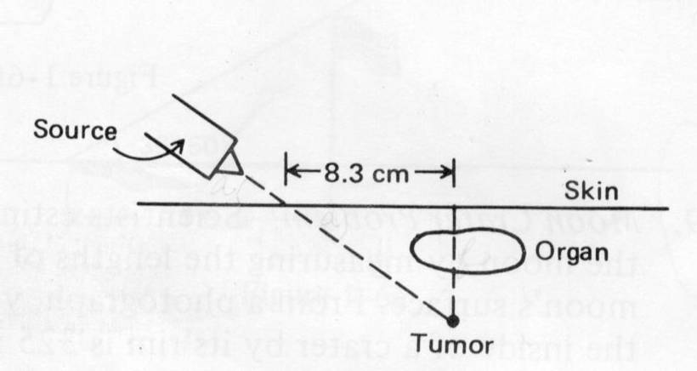 b.) How far will the beam have to travel through the patient’s body before reaching the tumor?