Name:________________________

**1.7 Graph Attributes**

For each equation, list the maximum number of extrema the graph of the polynomial could have. Check on your calculator.

1. 
2. 
3. 
4. 

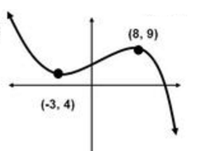For each graph, find all local extrema and label as a local min or max. List the intervals on which the function is increasing and decreasing and the end behavior of the function.

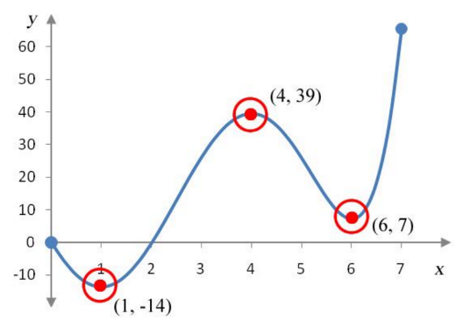5. 6.

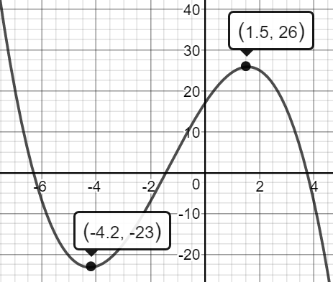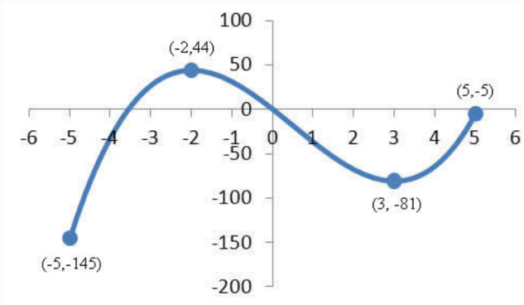

7. 8.

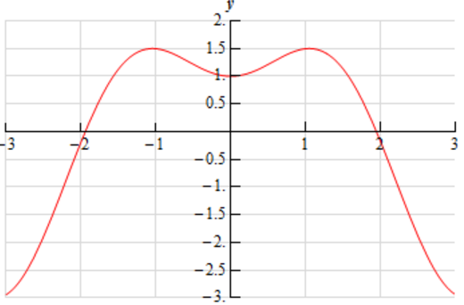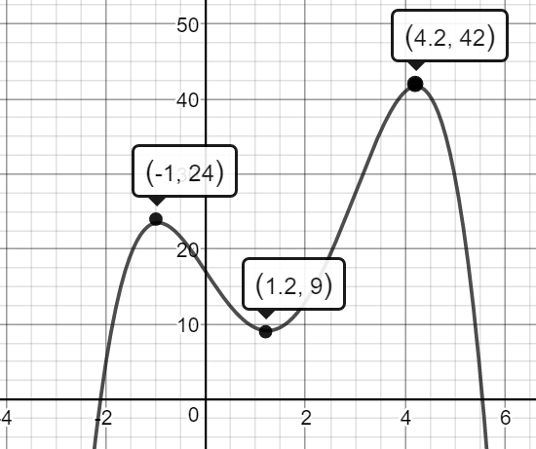

9. 10.

Graph the function to determine all relative maxima, relative minima, the intervals on which each function is increasing and decreasing, and the end behavior.

11.  12**.** 

