Name:___________________________

1.8 The Unit Circle

Find the exact value:

1.  2.  3.  4. 

5.  6.  7.  8. 

9. If cscθ > 0, then θ lies in quadrant(s)_____

10. If cscθ < 0, and secθ > 0 then θ lies in quadrant(s)_____

11. Which of the following points is not on the unit circle?

A)  B)  C) 

12. Which radian value is associated with the coordinates

13. In the accompanying diagram of a unit circle, the ordered pair (x,y) represents the locus of points for the circle. Which ordered pair is equivalent to (x,y)?

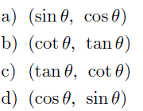 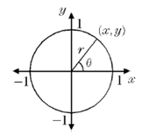

14. Find 2 negative and 3 positive angles, expressed in radians, for which the point on the unit circle corresponds to each angle is:



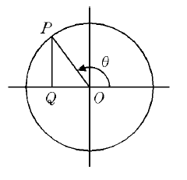15. In the accompanying diagram, circle O is a unit circle. What function is represented by the length of segment OQ?

1. 
2. 
3. 
4. 

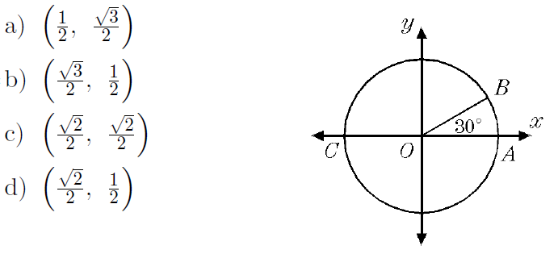16. In the diagram of circle O and . What are the coordinates of B?

17. In the figure . What are the coordinates of point P?

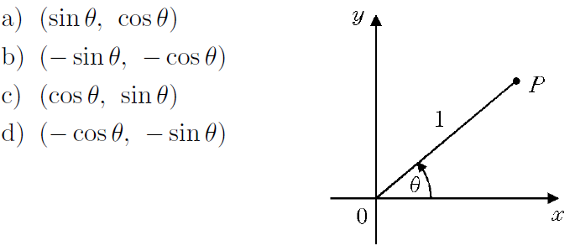

18. In the diagram, the ordered pair (x,y) represents the point where the terminal side of θ intersects the unit circle. If , what is the value of x in simplest form?

