**Student Practice – Ellipse**

Name ___________________________ Date_________________________ Period ________________

Identify each equation as a circle or an ellipse. If it is an ellipse draw the graph and label the center, vertices, co-vertices.

1. 
2. 
3. 
4. 
5. 

Find the foci and vertices of each ellipse:

1.  7.  8. 

Write the equation in standard form.

9. 49x2 + 64y2 – 3136 = 0 10. 

Write the equation in standard form.

11. 12.

Write an equation in standard form, and sketch a graph. Label all critical values of your graph.

1. center at origin; endpoints of major axis (4, 0) (-4, 0); *y*-intercepts at (0, 2) and (0, -2)
2. center at origin; foci at (0, 3) and (0, -3); major axis 10 units long
3. center at origin; one focus at (5, 0); one endpoint of major axis at (7, 0)
4. endpoints of the axes are (1, 1) (5, 1) (3, 6) (3, -4)

17. Statuary Hall is an elliptical room in the United States Capitol in Washington, D.C. The room is 46 feet wide and 96 feet long. Because of a reflective property of an ellipse, a person standing at one focus can hear even a whisper spoken by a person standing at the other focus. (John Quincy Adams is said to have used this feature of the room to overhear conversations.)

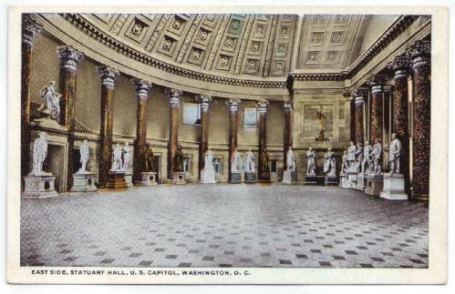

* 1. Find an equation of the ellipse.
  2. How far apart are the two foci?

18. Kidney stones can be treated using a lithotripter. An electrode at one focus of an elliptical reflector sends high-energy shock waves to crush the kidney stone at the other focus. Suppose the length of the major axis of the ellipse is 40 centimeters and the length of the minor axis is 20 centimeters.

1. Write the equation of the ellipse.
2. How far from the kidney stone should the electrode be place in order to shatter it?