**Practice – Hyperbolas**

Name ______________________________________ Date __________________________ Period______

Write the equation in standard form for each hyperbola.

1. 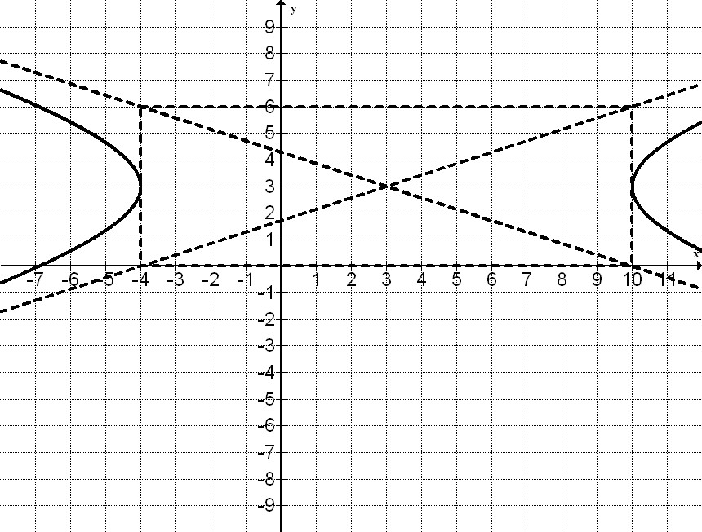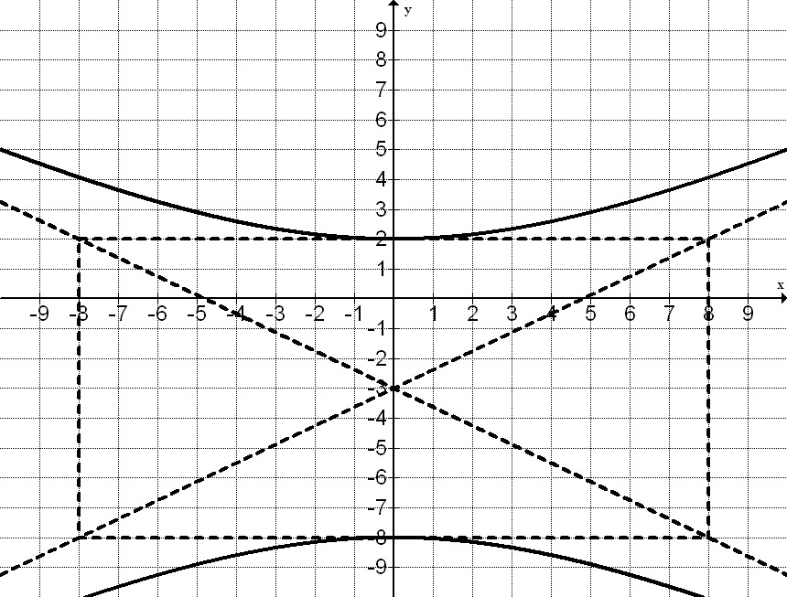 2.

Find the critical values for each hyperbola and then graph.

1. 

Center _______________

Vertices _________________________

Co-vertices _________________________

Foci ____________________________

Slopes of Asymptotes ____________

Domain ______________

Range_______________

1. 

Center _______________

Vertices _________________________

Co-vertices _________________________

Foci ____________________________

Slopes of Asymptotes ____________

Domain ______________

Range_______________

Domain ______________

Range_______________

1. 

Center _______________

Vertices _________________________

Co-vertices _________________________

Foci ____________________________

Slopes of Asymptotes ____________

Domain ______________

Range_______________

1. 

Center _______________

Vertices _________________________

Co-vertices _________________________

Foci ____________________________

Slopes of Asymptotes ____________

Domain ______________

Range_______________

1. What happens to the graph of  as the value of *a* increases? What happens to the graph of  as the values of *b* increase?
2. What is the length of the conjugate axis of the hyperbola with equation 
3. 7
4. 11
5. 14
6. 22
7. Find an equation of a hyperbola with vertices  and foci .
8. The hyperbola is centered at (2, -3) and has a horizontal transverse axis. The distance between the vertices is 14 and the length of the conjugate axis is 4. Find the equation of the hyperbola.
9. Given . Write the equation in standard form and sketch a graph.
10. Write the equation of the hyperbola centered at the origin with vertex at (6, 0) and asymptotes with equations 
11. What is the slope of one of the asymptotes of the graph of 