**Polynomial Test Review**

Solutions will be at mskmath.com

If you need more examples, finish your online quiz (or redo it!) and homework, you have lots of them there!

*YOU MUST BE ABLE TO FACTOR!!!! (1.1)*

* GCF, sum and difference of cubes/squares, 3 term, 4 term, etc.
  + No extra examples, look over your bonus point quiz, the 50 question hw assignment, the other assignments that required factoring. You’ve had lots of practice so far ☺

*Polynomial Operations (1.2)*

* Be able to add, subtract, multiply, and use both synthetic and long division
  + Polynomial operations homework evens for extra practice
* Identify the degree and leading coefficient of a polynomial (and the corresponding end behavior)
  + ex: y = -3x7 + x5 - 3x2 + 2
  + ex: y = 2x(x-4)2(x+2)3(x-3)4

*Parent Functions & Symmetry (1.3)*

* Know ALL your parent functions, including their domain & range, symmetry, and increasing/decreasing.
* Identify whether functions are EVEN (symmetric over the y-axis), ODD (symmetric about the origin), or NEITHER.

*Piecewise Functions (1.4 and 1.5)*

* Be able to graph, evaluate, and write the equation for piecewise functions
  + Ex: Graph the function 
  + 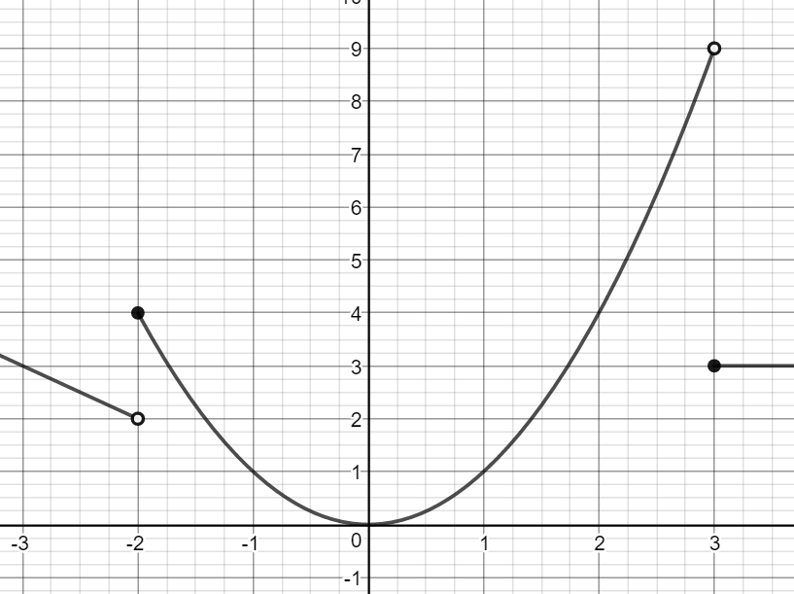Ex: Use the function to evaluate f(-2), f(-1), f(0), f(2) and f(7)
  + Write a piecewise function for the graph:

*Graphing Polynomials (1.6)*

* Know end behavior, x and y-intercepts, and multiplicity of 0’s
  + Ex: Graph
    - 1. P(x) = -2x3 - x2 + x
    - 2. P(x) = x5 - 9x3
    - 3. P(x) = -2(x-1)(x-2)2(x+1)3

*Graph Attributes (1.7)*

* Identify relative minimums/maximums, intervals where graphs are increasing/decreasing, and end behavior
  + Ex: 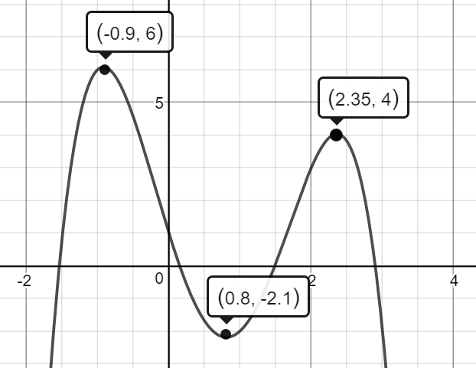

*Using a Calculator (1.8)*

* Be able to find minimums, maximums, intervals where the graph is increasing/decreasing, end behavior, intercepts, and use these things to solve word problems with applications
  + Look over your previous word problem homework
  + Ex: f(x) = x4 – 3x3 – 3x2 + x – 2
  + Ex: f(x) = -x3 – 4x2 - x + 3



You got this!!