Name:___________________

Polar and Parametric Test Review

***Part 1: Polar (all non-calculator)***

*Plot the coordinates and convert from polar coordinates to rectangular coordinates*

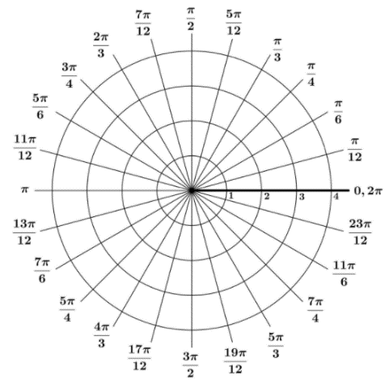1. 

2. 

3. 

4. 

*Convert from rectangular coordinate to polar coordinates*

5.  6.  7. 

*Convert the equation from rectangular to polar*

8.  9. 

*Convert the equation from polar to rectangular*

10.  11. 

*Write the type of graph, make a table, and draw the graph*

12.  13. 

Type: Type:

*Write the type of graph, make a table, and draw the graph*

14.  15. 

Type: Type:

15. Describe the difference between the graph of  and 

***Part 2: Parametric (non-calculator)***

*Graph the parametric equations (show direction with arrows) and eliminate the parameter to find a rectangular equation*

**1.**  **2.**   **3**. 

**4**.  **5**.  **6**. 

*Write a set of parametric equations to model the following situations*

**7**. An ellipse, centered at the origin, with end points (0,-2), (0,2), (-3,0), (3,0) that rotates *clockwise*

**8**. A circle centered at (2,3) with a radius of 4 that rotates *counter-clockwise*

**9.** A wall 300 feet away that is 20 ft tall with

a) t-max 10 b)t-max 2 c)t-max 5

**10**. A cannon shoots a ball from 5 feet off the ground at an initial velocity of 200 ft/sec at an angle of 39o, with a breeze blowing with the ball at 5 ft/sec

***Part 3 Parametric-Calculator***

**11**. A long jumper leaves the ground with an initial velocity of 31 ft/sec at an angle of 22-degrees. Determine the time of flight, the horizontal distance traveled, and the peak height of the long-jumper.

**12**. A football is kicked with an initial velocity of 44 ft/s at an angle of 55-degrees. If the cross bar of the goal post is 10 feet high and 45 feet away, will the kick be good?  What if the wind was blowing in at 3 ft/s?

**13.** A baseball player hits a ball with an initial velocity of 130 ft/sec. There is a wind blowing with the ball at 3 ft/sec. The angle of elevation of the ball off the bat is 25o and the ball hits the bat 2 ft off the ground. Give the set of parametric equations for the path of the ball. At what time is the ball 200 ft away? Will the ball clear a 10 ft high fence 400 ft away?