**12.1 Polar Basics** Name: _______________________________________

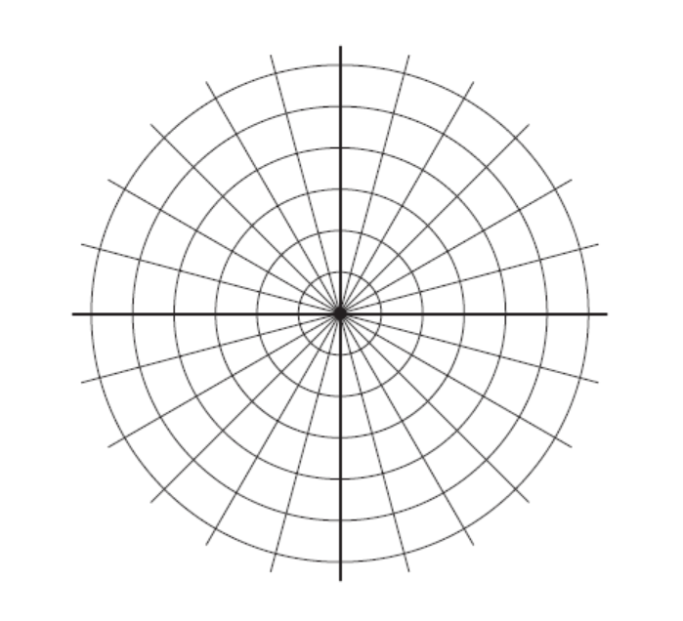Plot the point that has the given polar coordinates.

1. 
2. 

Plot the point that has the given polar coordinates. Then give two other polar coordinate representations of the point, one with r < 0 and the other with r > 0.

1. 
2. 

A point is graphed in polar form. Find its rectangular coordinates.

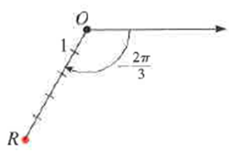

Find the rectangular coordinates for the point whose polar coordinates are given.

1. 
2. 
3. 

Convert the rectangular coordinates to polar coordinates with r > 0 and 

1. (-1,1)
2. 
3. (-6,0)

Convert the equation to polar form.

1. 
2. 
3. 
4. 

Convert the polar equation to rectangular form.

1. 
2. 
3. 
4. 