Name:______________________________________________ 2.4 Tan, Cot, Sec, Csc Graphs
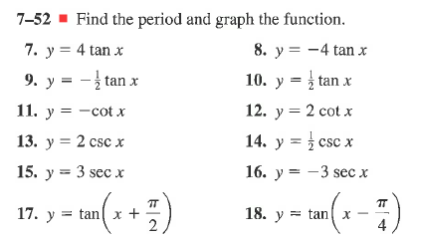
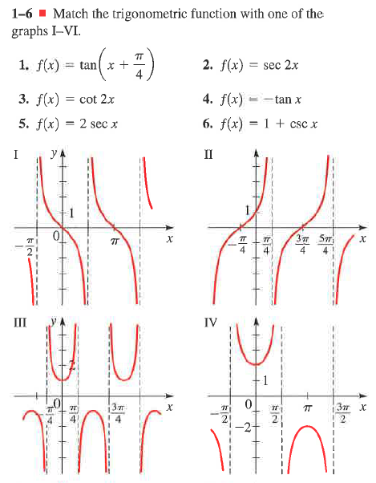
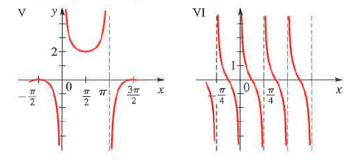
Pg 441 1-6,7,11,13,15,17

