**Student Practice – Ellipse Day 1**

Name ___________________________ Date_________________________ Period ________________

Identify each equation as a circle or an ellipse. If it is an ellipse draw the graph and label the center, vertices, co-vertices. State the domain and range.

1. 
2. 
3. 
4. 
5. 

Find the foci and vertices of each ellipse:

1.  7.  8. 

9.  10.  11. 

Write the equation in standard form.

12. 49x2 + 64y2 – 3136 = 0 13. 

Write the equation in standard form.

14. 15.

1. Statuary Hall is an elliptical room in the United States Capitol in Washington, D.C. The room is 46 feet wide and 96 feet long. Because of a reflective property of an ellipse, a person standing at one focus can hear even a whisper spoken by a person standing at the other focus. (John Quincy Adams is said to have used this feature of the room to overhear conversations.)

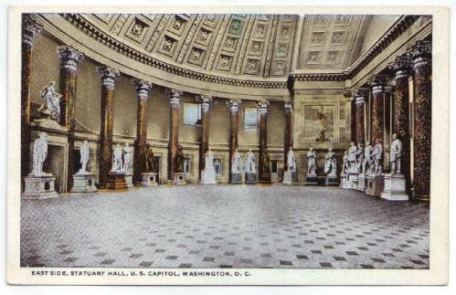

* 1. Find an equation of the ellipse.
  2. How far apart are the two foci?

1. An elliptically shaped garden is surrounded on all sides by a wooden walkway. The garden is 15 meters long and 8 meters wide. The walkway is 2 meters wide.
2. Find the equation describing only the garden.
3. Find the equation describing the garden and walkway together.
4. Find the area of just the walkway ().