**12.2 Polar Graphs Day 1** Name: ___________________________

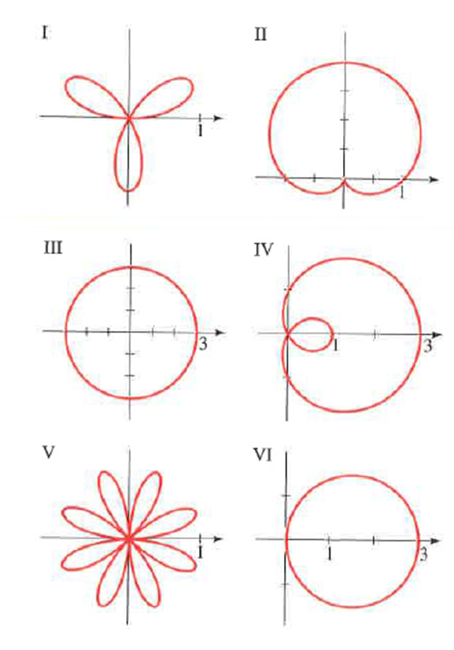Match the polar equation with the graphs labeled I-VI.

1. 
2. 
3. 
4. 
5. 
6. 

Sketch the graph of the polar equation.

1. 

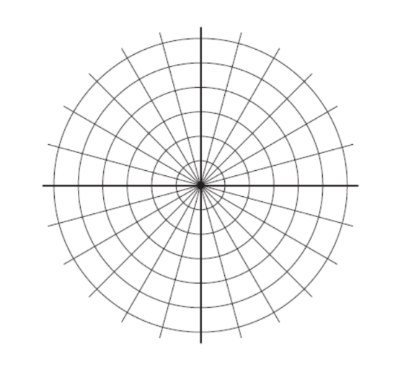

1. 
2. 



1.  
2. 
3. 



1. 

