Name:______________
Definition of Derivatives Part 2

1. In your own words, explain what a derivative is

2. State the limit definition of a derivative

3. Match the function (a-d) with the graph of its derivative (I-IV)
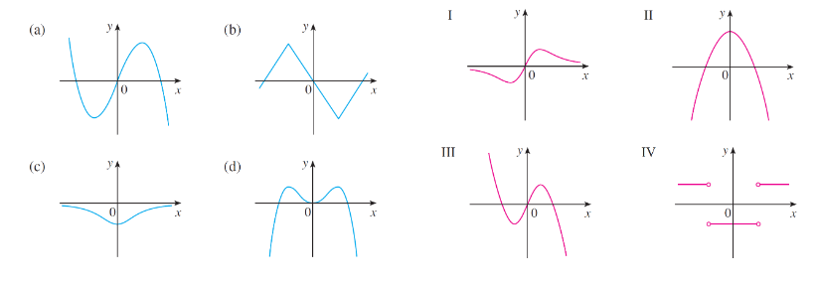

For #4-6, use the limit definition to find the derivative of the function
4. f(x) = -2x + 4

5. f(x) = $\frac{1}{x}$

6. f(x) = $\sqrt{x-2}$

7. Using f(x) = -3x², predict if the slope of the tangent line will be positive or negative at
x = -3, x = 0, and x = 1. Then find the actual slope of the tangent line at these points.

8. The function h(t) = -16t² + 60t + 80 measures height in terms of time.
a) Find the average velocity from t =[0,2]

b) Find the derivative of the function

c) Using the derivative, find the instantaneous velocity at t = 0, t = 1, and t = 2

9. Use the definition of the derivative to show that f’(0) does not exist where f(x) = |x|.

10. For the function f(x) = x² + 2x + 1, find the slope of the tangent line at x = -3

