**11.3 Practice – Hyperbolas Day 1**

Name ______________________________________ Date __________________________ Period______

Write the equation in standard form for each hyperbola.

1. 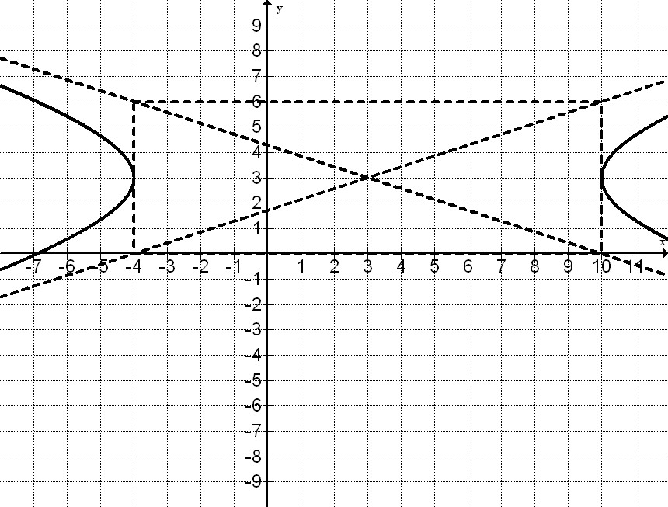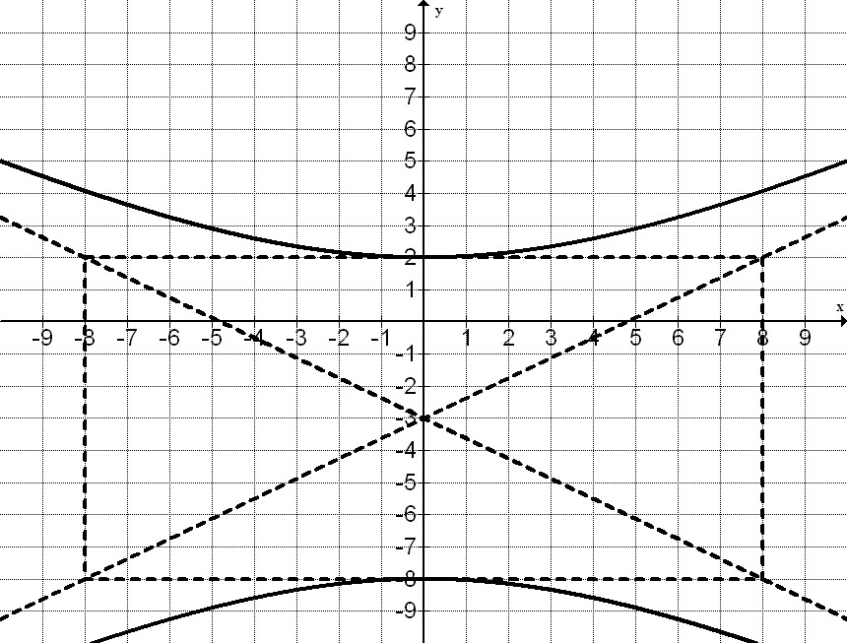 2.

Find the critical values for each hyperbola and then graph.

1. 

Center _______________

Vertices _________________________

Co-vertices _________________________

Foci ____________________________

Slopes of Asymptotes ____________

1. 

Center _______________

Vertices _________________________

Co-vertices _________________________

Foci ____________________________

Slopes of Asymptotes ____________

1. 

Center _______________

Vertices _________________________

Co-vertices _________________________

Foci ____________________________

Slopes of Asymptotes ____________

1.  

Center _______________

Vertices _________________________

Co-vertices _________________________

Foci ____________________________

Slopes of Asymptotes ____________

1. 

Center _______________

Vertices _________________________

Co-vertices _________________________

Foci ____________________________

Slopes of Asymptotes ____________

1. 

Center _______________

Vertices _________________________

Co-vertices _________________________

Foci ____________________________

Slopes of Asymptotes ____________

1. 

Center _______________

Vertices _________________________

Co-vertices _________________________

Foci ____________________________

Slopes of Asymptotes ____________

1.  

Center _______________

Vertices _________________________

Co-vertices _________________________

Foci ____________________________

Slopes of Asymptotes ____________