**4.2 Inverse Parent Functions**

SINE

|  |  |
| --- | --- |
| **x** | **y** |
|  |  |
|  |  |
|  |  |
|  |  |
|  |  |

|  |  |
| --- | --- |
| **x** | **y** |
|  |  |
|  |  |
|  |  |
|  |  |
|  |  |

**Restricted Range:**

COSINE

**Restricted Range:**

TANGENT

**Restricted Range:**

**4.2 The rest of the inverse trig functions…** Name: ___________________________

Remember… csc is the reciprocal of ___________________. Sec is the reciprocal of __________________.

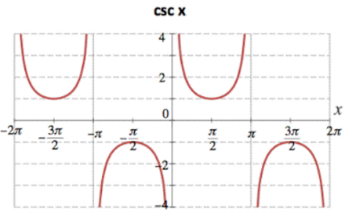Part 1. If the restricted range of the inverse sine function is _____________, what is the restricted range of the inverse cosecant function?

Fill in the table with the appropriate cosecant values

|  |  |
| --- | --- |
| x | Csc(x) |
|  |  |
| 0 |  |
|  |  |

Remember, to find an inverse of a function, switch your x & y values.

|  |  |
| --- | --- |
| x | Csc-1(x) |
|  |  |
|  |  |
|  |  |

If a function value is undefined, what attribute will appear on the graph? HINT: think of the graph of normal cosecant. What happens every  radians?

Sketch the graph of below. Label each critical point and any horizontal asymptotes.

Part 2. If the restricted range of the inverse cosine function is _____________, what is the restricted range of the inverse secant function?

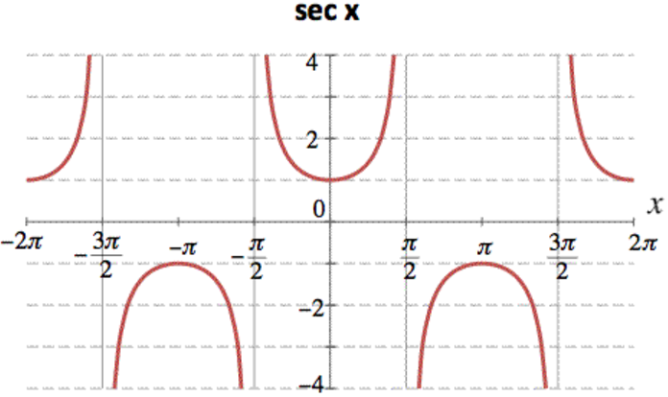Fill in the table with the appropriate secant values

|  |  |
| --- | --- |
| x | sec(x) |
| 0 |  |
|  |  |
|  |  |

Find your inverse critical values and fill in the table below.

|  |  |
| --- | --- |
| x | sec-1(x) |
|  |  |
|  |  |
|  |  |

What happens at x=?

Sketch the graph of below. Label each critical point and any horizontal asymptotes.

Part 3. The restricted range of the inverse cotangent function is . What do the parenthesis tell you will 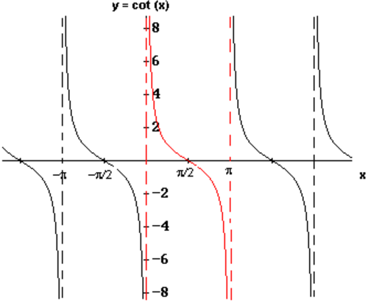happen at those end points?

Fill in the table with the appropriate cotangent values

|  |  |
| --- | --- |
| x | cot(x) |
| 0 |  |
|  |  |
|  |  |
|  |  |
|  |  |

Find your inverse critical values and fill in the table below.

|  |  |
| --- | --- |
| x | cot-1(x) |
|  |  |
|  |  |
|  |  |
|  |  |
|  |  |

What happens at x=0 and x=?

Sketch the graph of below. Label each critical point and any horizontal asymptotes.