Name: _________________________

**7.5 Polynomial Graphs**

List the degree and find the end behavior of each graph

1. –x3 + 3x -7 2. -x(x-3)3(x-2)(x+1)4

Degree:   Degree:  

1. (x-2)(x+7)3  4. 2x4-3x3 + 2x – 5

Degree:   Degree:  

Match the polynomial with one of the graphs. Tell your reasoning for each choice.

5. P(x) = x(x2 – 4)

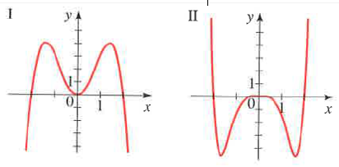

6. Q(x) = -x2(x2 – 4)

7. R(x) = -x5 + 5x3 – 4x

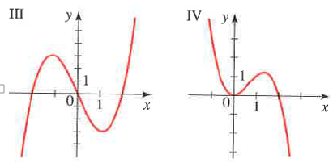

8. S(x) = x6 – 2x4

9. T(x) = x4 + 2x3

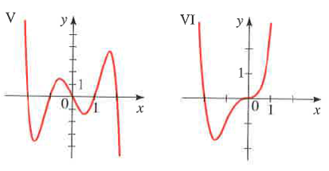

10. U(x) = -x3 + 2x2

Find all zeros and sketch the graph. Factor if needed

1. P(x) = x3 – x2 -6x 12. P(x) = –x3 + x2 +12x
2. P(x) = x3 + x2 – x – 1 14. P(x) = x4 – 3x2 - 4

15. P(x) = x(x-3)2(x+2)3 16. –(x-1)3(x+7)4(x-3)