**7.4 Polynomials with a Calculator** Name: ________________________

In Exercises 2-7, find relative maxima, relative minima, and the intervals on which each function is increasing and decreasing.

**2**. 

**3.** 

**4**. 

**5.** 

**6.** 

**7.** 

**8**. A rectangular area is to be fenced against an existing wall. The three sides of the fence must be 1050 ft long. Find the dimensions of the maximum area that can be enclosed. What is the maximum area?

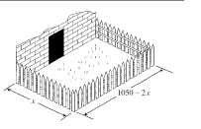

**9**. A 300-in. piece of wire is cut into two pieces. Each piece of wire is used to make a square wire frame. Let *x* be the length of one piece of the wire.

1. Find an algebraic representation that gives the total area of the 2 squares as a function of *x.*

b. Find a complete graph on your calculator of this algebraic representation.

c. What portion of the graph of the algebraic representation represents the problem situation?

d. Find the lengths of the two pieces of wire that produce two squares of minimum total area.

e. Is there a way to cut the wires so that the area of the two squares is a maximum total area?

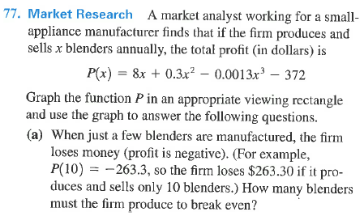

**10**

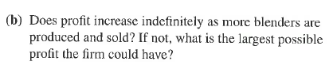

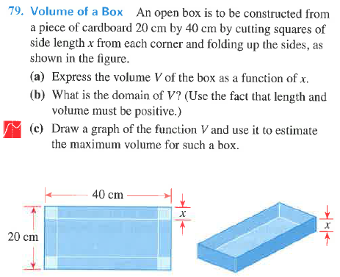

**11**