Polynomial Test Review
Solutions will be at mskmath.com
If you need more examples, look back at your old quizzes and homework, you have lots of them there!

YOU MUST BE ABLE TO FACTOR!!!! (7.1)
- GCF, sum and difference of cubes/squares, 3 term, 4 term, etc.
  - No extra examples, look over your bonus point quiz, the 50 question hw assignment, the other assignments that required factoring. You’ve had lots of practice so far

Polynomial Operations (7.2)
- Be able to add, subtract, multiply, and use both synthetic and long division
  - Polynomial operations homework evens for extra practice
- Identify the degree and leading coefficient of a polynomial (and the corresponding end behavior)
  - ex: y = -3x⁷ + x⁵ - 3x² + 2
  - ex: y = 2x(x-4)²(x+2)³(x-3)⁴

Factoring with Synthetic Division (7.3)
- Use the rational zero theorem to find possible rational zeros
  - Include positive and negative
  - P/Q where P- factors of constant term, Q- factors of leading coefficient
  - ex: Find the possible rational zeros for the polynomial 4x⁴ – 7x³ – 4x + 12
- Test numbers with synthetic division. If you get 0 as a remainder, the number in the box is a zero of the polynomial and x-c is a factor of the polynomial. Continue until you can factor the remaining polynomial or use the quadratic formula
  - Ex: If 3 is a zero of x³ + 3x² – 10x – 24, factor completely
  - Ex: Factor completely: x³ – x² – 8x + 12
  - Ex: Find the zeroes of: x⁴ – 5x² + 4

Piecewise Functions (7.4)
- Be able to graph, evaluate, and write the equation for piecewise functions
  - Ex: Graph the function
  - Ex: Use the function to evaluate f(-2), f(-1), f(0), f(2) and f(7)
  - Write a piecewise function for the graph on the back:

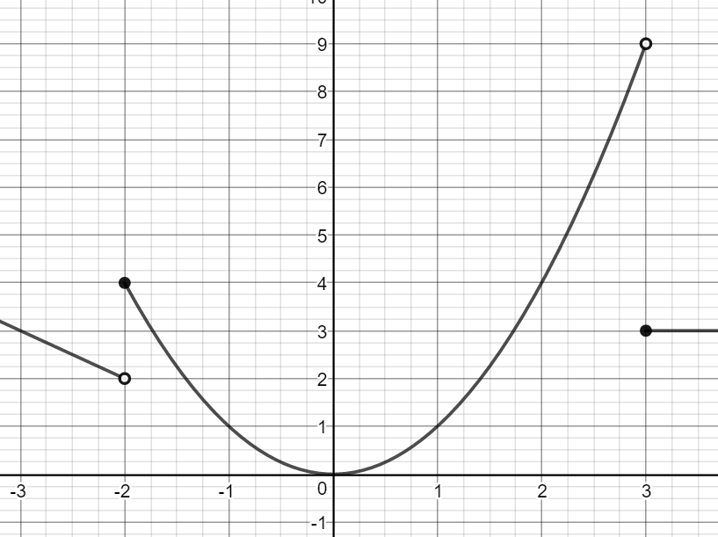

Graphing Polynomials (7.5)
- Know end behavior, x and y-intercepts, and multiplicity of 0’s
  - Ex: Graph
    - 1. P(x) = -2x³ - x² + x
    - 2. P(x) = x⁵ - 9x³
    - 3. P(x) = -2(x-1)(x-2)²(x+1)³

Graph Attributes (7.6)
- Identify relative minimums/maximums, intervals where graphs are increasing/decreasing, and end behavior
  - Ex: 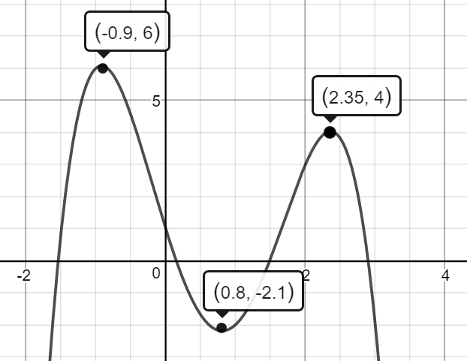

Using a Calculator (7.7)
- Be able to find minimums, maximums, intervals where the graph is increasing/decreasing, end behavior, intercepts, and use these things to solve word problems with applications
  - Look over your previous word problem homework
  - Ex: f(x) = x⁴ – 3x³ – 3x² + x – 2
  - Ex: f(x) = -x³ – 4x² - x + 3

