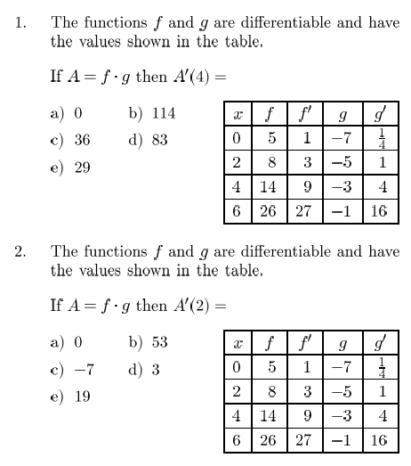13.7 Quotient Rule

Name:_________________

Find f’(x) for each function

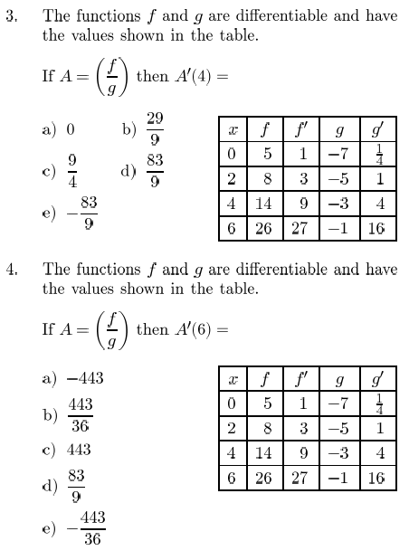

12. Suppose the amount of air in a balloon at

any time t is given by.



Determine if the balloon is being filled

or drained with air at t=4