Name:________________________

8.4 Graph Attributes

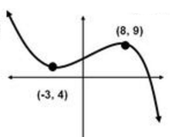For each graph, find all local extrema and label as a local min or max. List the intervals on which the function is increasing and decreasing and the end behavior of the function. Assume all graphs have arrows at the ends.

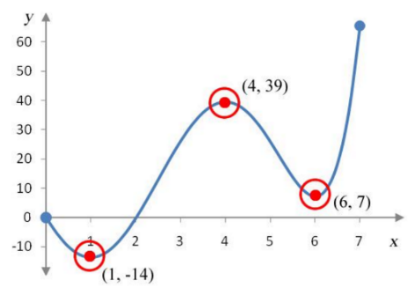1. 2.

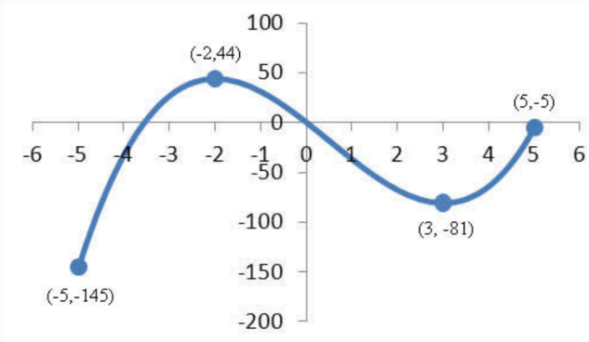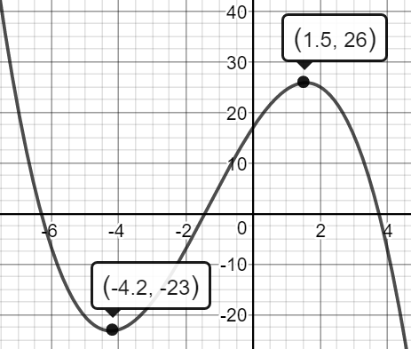3. 4.

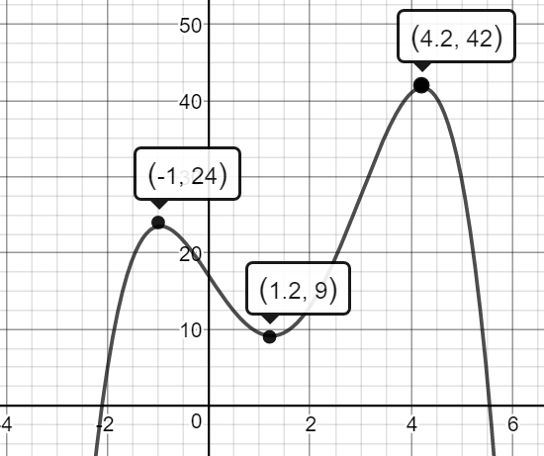

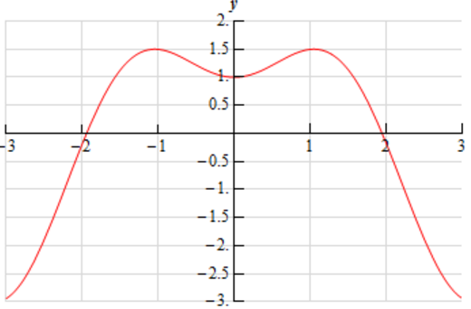5. 6.

Using a graphing calculator, determine all relative maxima and relative minima

7.  8**.**  9**.** 