Name:

8.6 Polynomials with a Calculator

In problems 1-3, find relative maxima, relative minima, and the intervals on which each function is increasing and decreasing.

**1**. 

**2.** 

**3.** 

**4**. A rectangular area is to be fenced against an existing wall. The three sides of the fence must be 1050 ft long. Find the dimensions of the maximum area that can be enclosed. What is the maximum area?

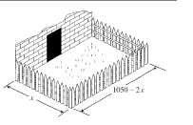

5. A market analyst working for a small appliance manufacturer finds that if the firm produces and sells x blenders annually, the total profit (in dollars) is

P(x) = 8x + .3x2 - .0013x3 – 372

Graph the function P in an appropriate viewing rectangle and use the graph to answer the following questions.

a)When just a few blenders are manufactured, the firm loses money (profit is negative). How many blenders must the firm produce to break even?

b) Does profit increase indefinitely as more blenders are produced and sold? If not, what is the largest possible profit the firm could have?

6. An open box is to be constructed from a piece of cardboard 20 cm by 40 cm by cutting squares of side lengths x from each corner and folding up the sides, as shown in the figure.

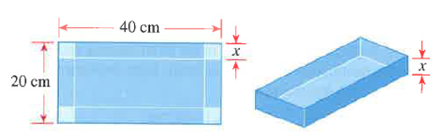

a) Express the volume, V, of the box as a function of x

b) What is the domain of V? (Use the fact that length and volume must be positive.)

c) Use your calculator to find a graph of the function V and use it to estimate the maximum volume for such a box