Name:__________________ Log and Exponent Review

**Laws of Logs**:

Rewrite the exponential equation as a log

**1. 2.  3.  4. **

Use the laws of logarithms to expand the expression

**5**.   **6**.  **7.**  **8.**

Use the laws of logarithms to combine the expression into a single log

**9.**  **10**.  **11**. 

**Exponent and Log Graphs:** Match the graph with the equation

**1.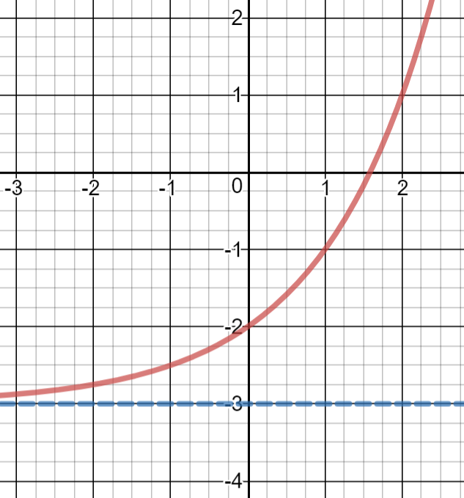 2.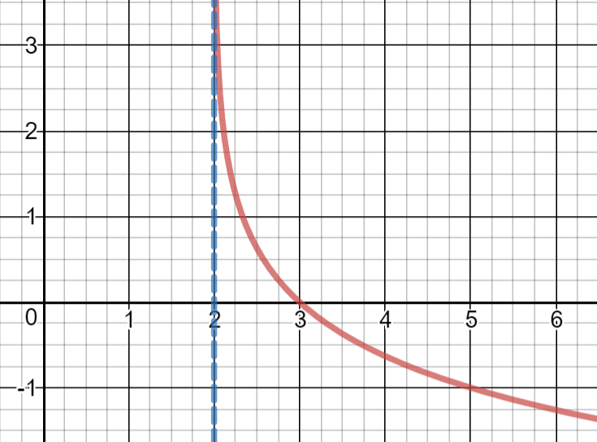 3.**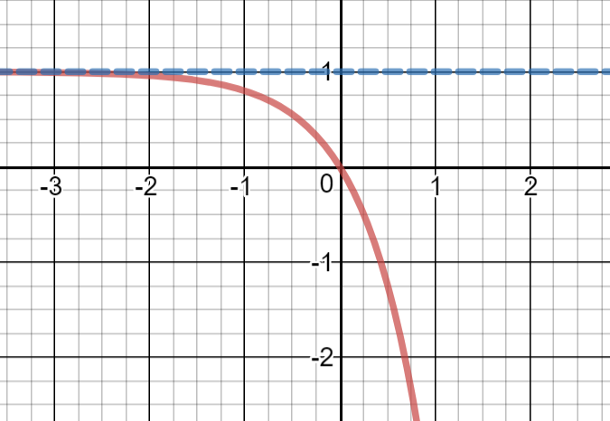

A.  A.  A. 

B.  B.  B. 

C.  C.  C. 

D.  D.  D. 

**4.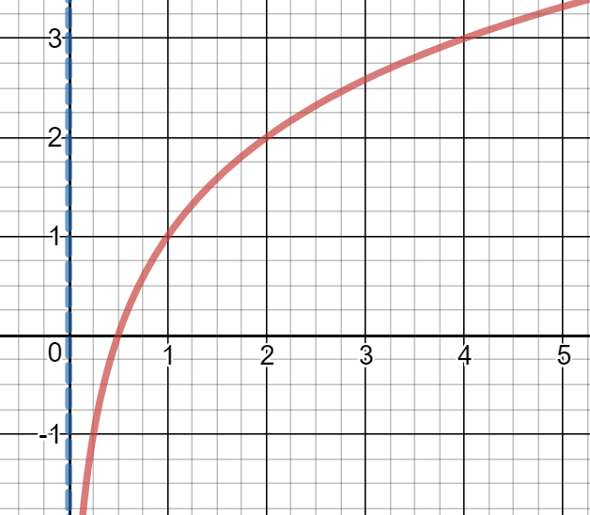 5.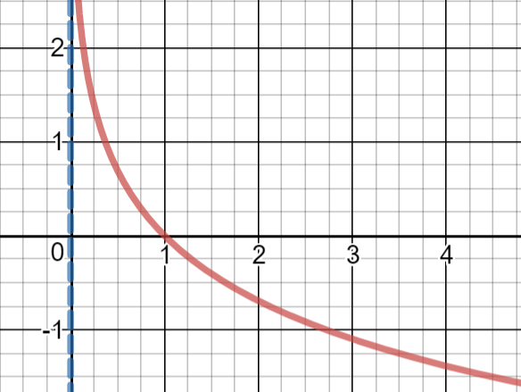 6.** 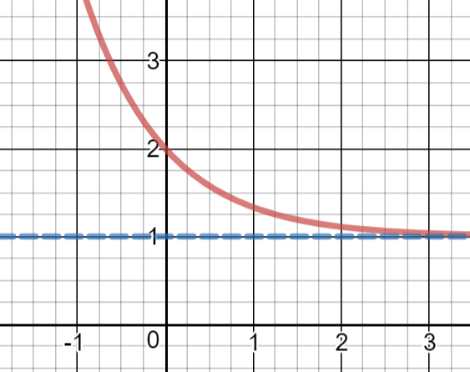

A.  A.  A. 

B.  B.  B. 

C.  C.  C. 

D.  D.  D. 

Find the domain of the function in interval notation

**7**.  **8** 

**Word Problems**: This is the calculator part. Work the word problems from last week that you haven’t done already

**Solving Log Equations/Exponent Rules**:

**1.  2.  3.  4. **

**5. 6. 7.  8. **

**9.  10.  11.  12. **

**13.  14.  15. **

**16. 17.  18. **

**Solve each equation. Leave your answer in terms of log, ln or e**

**19.  20.  21. **

**22.  23. **