Name:_____________________ Per:_______

Trig Review!

Look at how much stuff you’ve learned so far this year! On this review you’ll find some examples of the topics we’ve learned about. You do not need to work out every question on the review!!! Skip around and work the types of questions you’ve struggled with or don’t remember. You also should look at your notes and old quizzes and tests to see what material you don’t remember or struggled with. Questions marked with *** are questions you can use a calculator for. The test will be split into a non-calculator portion on Thursday and a calculator portion on Friday. If you are absent, you will need to arrange a time with your partner next week Monday or Tuesday to make up the portion you missed

**Unit 1- Right Triangle Trig**

Find coterminal angles

Graph angles in radians and degrees

Find radian values on the unit circle

Convert radians to degrees

Find reference angles

Exact values on the unit circle

***Trig in the real world

**Unit 2- Trig Graphing**

Graph sinusoidal functions

Know tan, cot, sec, csc parent functions

Write equations of sinusoids

***Model real world problem with sinusoidal functions

**Unit 3- Inverses**

Evaluate inverse values between [0, 2π)

Find general solutions to trig equations

Evaluate principal inverse values

Evaluate trig composition with exact values and variables

***Solve trig functions algebraically

**Unit 1- Right Triangle Trig**

**1**. Find 2 angles that are coterminal to  and 2 angles coterminal to 40O

**2.** Convert 500 degrees to radians

**3.** Convert  radians to degrees

*Graph the angle and find it’s reference angle*

**4**. 6000 **5.** 

*Find the exact value*

**6**. sin **7**. cos **8**. cot **9.** sec

**10**. The terminal side of an angle θ in standard position passes through the point (5,2). Find the 6 trigonometric functions of θ

**\*\*\*11.** A 32 ft long wire is attached to the top of a flagpole. The wire makes an angle of 17o with the ground. How tall is the flogpole?

**\*\*\*12.**A 12 ft 11 in tall tree casts a 10 inch long shadow What is the angle of elevation of the sun?

**Unit 2- Graphing Trig Functions**

*Graph 2 cycles of the function*

**13.**  **14.** 

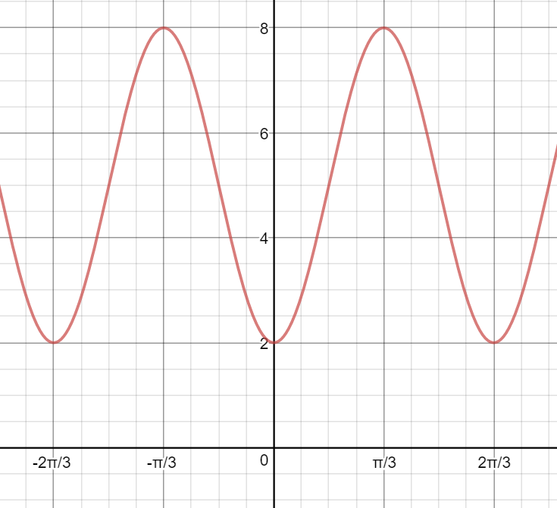*Write the equation of the graph*

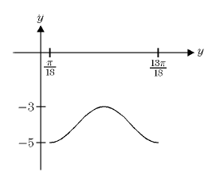

**15**. ___________________ **16**. _________________

**17.** In the function, explain how the constants -4, -3, 2 and  affect the graph

**18.** Know the parent functions for tan, cot, sec and csc!!!

\*\*\***19.** Astronomers believe that the radius of a variable star increases and decreases with the brightness of the star. The certain variable star has an average radius of 25 million miles and changes by a maximum of 1.5 million miles from this average during a single pulsation. The time between periods of maximum brightness is 5.4 days. At the time you start recording, the star is at its average radius.

a) Find an equation that describes the radius (in millions of miles) of this star as a function of time in days.

b) What will be the first time the star will have a radius of 25.5 million miles?

c) What will the radius of the start be 12 days after you start recording?

**Unit 3- Inverses**

*Find the values of x where *

**20**.  **21**.  **22.** 

*Find the general solution to the equation*

**23.**  **24.** 

*Find the exact principle value*

**25.**  **26**. 

*Find the exact value or an equivalent algebraic expression*

**27.**  **28.**  **29.** 

**30.** tan-1(cos 0) **31.** sin(cos-1 x)  **32.** sin(arctan3 x)

*Solve for the general solution algebraically*

**\*\*\*\*33.** 