Name:______________

Quiz Review

**Find each limit algebraically:**

1.  2.  3.  4. 

25. Use the graph of g below:

a) State the intervals on which g is continuous.

b) Find the limit:

   

   

36. For the function g whose graph is given, state the value of the given quantity, if it exists. If it does not exist, explain why.

a)  b)  c) 

d)  e)  f) 

g)  h) 

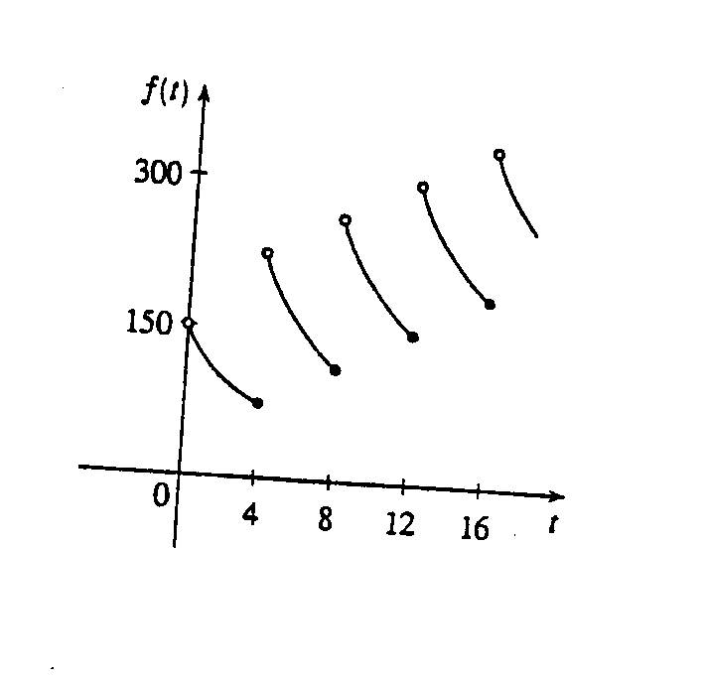7. A patient receives a 150-mg injection of a drug every 4 hours. The graph shows the amount  of the drug in the bloodstream after  hours. (Later we will be able to compute the dosage and time interval to ensure that the concentration of the drug does not reach a harmful level.) Find  and 

and explain the significance of these one-sided limits.

For #8-11: Draw the graph of f(x). Discuss the continuity of the graph, and find .

8.   9.  

10.   11.  

12. For what value of the constant c is the function f continuous on ?



13. Where is the function  discontinuous? What kind of discontinuities exist?

14. If the function f is continuous for all real numbers and if  when , then 

A) 1 B)  C) -1 D) 0 E) undefined

Find the value of the limit, if it exists



15.  16.  17. 

18.  19.  20. 