Name:______________________
Sinusoidal Modeling Project

This project will count as a quiz grade and will be due at the beginning of class Monday, October 19. You may work in a group of up to 4 people

Part One- Modeling the Motion of a Pendulum

As a simple pendulum swings back and forth, its displacement can be modeled using a standard sinusoidal equation of the form:
y = a cos (b(x - h)) + k

where y represent the pendulum’s distance from a fixed point and x represents the total elapsed time in seconds. In this project, y will use a motion detection device called a CBR (Calculator Based Ranger) to collect distance and time data for a swinging pendulum, then find a mathematical model that describes the pendulum’s motions.

Materials
1 meter of string
ball fastened to the end of the string
graphing calculator
calculator to CBR connection cable
CBR

Collecting the Data
Once the CBR is set up to collect time and distance readings for 2 seconds, start the pendulum swinging in front of the detector. Make sure only the string and washer/ball are in front of the detector and there is nothing in the path that would interrupt the data. Once you start the pendulum swinging in front of the detector, then activate the system.
Even though your calculator will gather the data for your scatter plot and regression equation, go ahead and record your data here .
Total elapsed time (seconds) | Distance from the CBR (meters) |  | Total elapsed time (seconds) | Distance from the CBR (meters) |  | Total elapsed time (seconds) | Distance from the CBR (meters)
0 |  |  | 0.7 |  |  | 1.4
0.1 |  |  | 0.8 |  |  | 1.5
0.2 |  |  | 0.9 |  |  | 1.6
0.3 |  |  | 1.0 |  |  | 1.7
0.4 |  |  | 1.1 |  |  | 1.8
0.5 |  |  | 1.2 |  |  | 1.9
0.6 |  |  | 1.3 |  |  | 2.0

Find a sinusoidal regression equation to model the data above
The data table below shows a sample set of data collected as a pendulum swung back and forth in front of a CBR.

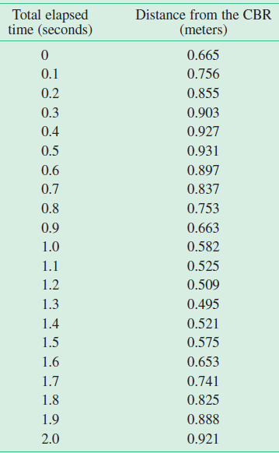
- On your calculator, graph a scatter plot for the data above. Make sure you find a window that fits this data.

- Find values for a, b, h and k so that the equation y = a cos(b(x-h)) + k fits the distance vs time data plot. You are not finding a sinusoidal regression yet. You are using the data above and your scatter plot to come up with the cosine equation that models the data.

- What are the physical meanings for the constants a and k in the modeling equation y = a cos(b(x-h)) + k?

- Which, if any, of the values of a, b, h and/or k would change if you used the equation y = a sin(b(x-h)) + k to model the data set?

- Use your calculator to find a sinusoidal regression equation to model this data set. Notice the calculator’s regression equation has not factored out “b.” Factor out b for your final sine equation below. Round a, b, h and k to three decimal places.

- Graph the cosine equation from #2 here. Make sure to number and label the x and y axes.
Using a red colored pencil, show the amplitude, a, on the graph.
Using a blue colored pencil, show the period of the function. Also show the calculation here for the period using the b value.
Using a green colored pencil, show the horizontal shift, h.
Using a black colored pencil, show the vertical shift, k.

- Graph the sinusoidal regression equation from #5 here. Use the equation where you factored out b. Make sure to number and label the x and y axes.

Using a red colored pencil, show the amplitude, a, on the graph.
Using a blue colored pencil, show the period of the function. Also show the calculation here for the period using the b value.
Using a green colored pencil, show the horizontal shift, h.
Using a black colored pencil, show the vertical shift, k.

8. Compare your equation from the given data to the equation you got from recording data with the CBR. Which parts of the equation were different? Why were they different?

