Name:________________

**Unit 2 Graphing Sinusoidal Functions Review**

1. 

A represents…. B represents…. BUT to find _____________, use the equation:

C represents… D represents…

sin starts at a _________ and cosine starts at a _______

2. Parent Functions

|  |  |  |  |  |
| --- | --- | --- | --- | --- |
| **Name** | **Equation** | **Graph** | **Period** | **Sinusoidal Axis** |
| Sine |  |  |  |  |
|  |  |  |  |  |
| Tangent |  |  |  |  |
|  |  |  |  |  |
|  |  |  |  |  |
|  |  |  |  |  |

Draw 2 cycles of each graph in radians.

3. (Radians)

A. Amplitude: ___________

B. Period: ___________

C. Sinusoidal Axis (midline): ____________

D. Phase Shift (horizontal shift): ____________

E. Maximum y-value: ____________

4. ) (Radians)

A. Amplitude: ___________

B. Period: ___________

C. Sinusoidal Axis (midline): ____________

D. Phase Shift (horizontal shift): ____________

E. Maximum y-value: ____________

5.  (Degrees)

A. Amplitude: ___________

B. Period: ___________

C. Sinusoidal Axis (midline): ____________

D. Phase Shift (horizontal shift): ____________

E. Maximum y-value: ____________

6.  (Degrees)

A. Amplitude: ___________

B. Period: ___________

C. Sinusoidal Axis (midline): ____________

D. Phase Shift (horizontal shift): ____________

E. Maximum y-value: ____________

Write the equation of the graph as either sine or cosine. Check the axis to see if the graph is in radians or degrees.

7. 8.

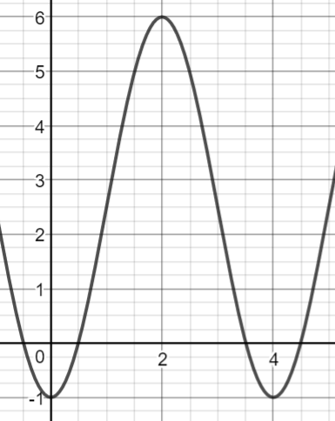 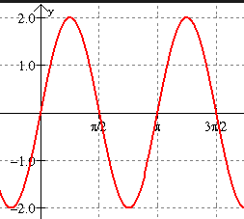

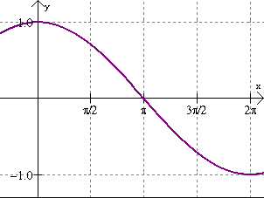

9. 10.

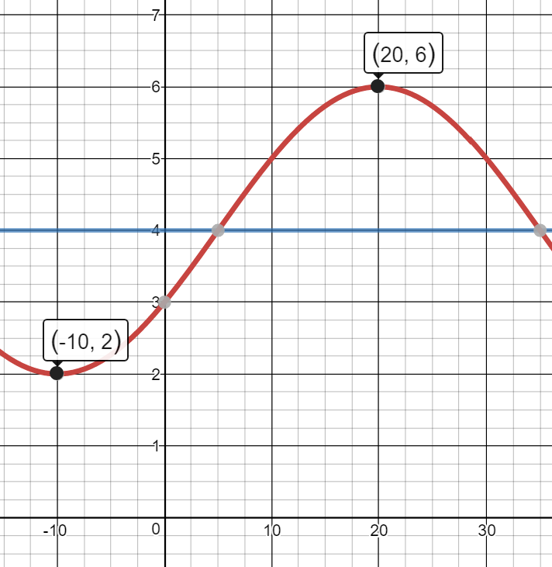.

11. 12.