Oblique Triangles Story Project
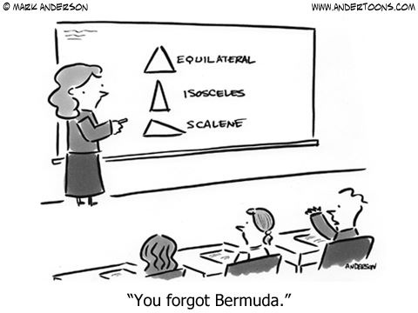
Oblique triangles are everywhere! Your job is to create a story that includes 5 oblique triangle word problems within it. You will need a visual product for your story. This can be an actual book, something digital, a video, etc. You will read your story to the class on Friday, January 26.
You will need to solve your problems separately and show all work. Label each problem by the type of triangle it is. You will need one problem for each of the triangles listed below. Please label what type of question each of your problems represents. Remember, these should be oblique triangles, so the given angle should not be 90 º
- Given SAS, solve for the 3rd side
- Given SSS, solve for an angle
- TWO: Given SSA, AAS, or ASA, solve for a side, solve for a side or angle (be careful of the ambiguous case!)
- Given any information, solve for the area of the triangle (or another shape made up of triangles)

This project will count as a TEST grade and is due at the beginning of class Friday, January 26. If your project is digital, use the google classroom assignment to submit a link or presentation.

Name: __________________________________________________________ Period: _______________

Description | 0 points | 1 point  For each problem | 3 points  For each problem | 5 points  For each problem | Points earned
Did you set up and solve the problem correctly? | No equation provided. | Equation has several errors in the set up or solution. | Equation has one error in the set up or solution. | Equation is set up and solved correctly. | /25
Does the problem make sense and fit into the story? | No problem provided. | Problem has several elements that do not make sense or does not fit into the story. | Problem has some elements that do not make sense. | Problem makes complete sense and fits in well. | /25
Description | 0 points | 10 points | 20 points | 30 points | Points earned
How visually pleasing is your story? | No visual provided. | Includes little detail, pictures and/or color, indicating a minimal amount of time and effort. | Includes some detail, pictures and/or color, indicating a moderate amount of time and effort. | Includes intricate detail, pictures and/or color, indicating a large amount of time and effort. | /30
Description | 0 points | 3 points | 5 points | 10 points | Points earned
Is your story creative? | Story is copied or unoriginal | Story does not contain details and is very generic | Story contains a few creative details or a creative theme that contributes to the reader’s enjoyment | Story has many creative details that contribute to the reader’s enjoyment. The student has really used their imagination | /10
Is your story turned in on time? | Story is not ready at the beginning of class 12/6 |  | Story is ready at the end of class 12/6 | Story is ready at the beginning of class 12/6 | /10

