**Algebra Review**

Below is a list of topics and practice problems you have covered so far this semester. You do not need to work out every question on the review. Skip around and work the types of questions you’ve struggled with or don’t remember. You also should look at your notes and old tests to see what material you don’t remember or struggled with. Questions marked with *** are questions you can use a calculator for. The test will be split into a non-calculator portion on Thursday and a calculator portion on Friday. If you are absent, you will need to arrange a time with your partner next week Monday or Tuesday to make up the portion you missed

**Unit 7 Polynomials**

Factoring (including using synthetic division and P/Q to factor)

Polynomial operations (add, subtract, multiply and divide with synthetic and long division)

Identifying the degree of a polynomial

Piecewise functions

Graphing a polynomial (multiplicity of zeros and end behavior)

End behavior (limit notation)

***Relative (local) extrema

Intervals where a graph is increasing/decreasing

**Unit 8 Inequalities and Rational Functions**

Using a sign chart for polynomial inequalitites

Finding asymptotes, intercepts and removable discontinuities for rational functions

Graphing rational functions

Rational inequalities

**Unit 9 Logarithms and Exponential Functions**

Rewriting exponents and logs (including natural log)

Exponent rules (including negative and fraction exponents)

Condensing and expanding logs

Solving log and exponential equations

Log and exponential graphs (including domain for log functions)

***Exponential growth and decay

**\*\*\*Unit 10 Conics (this whole unit will be on the calculator portion)**

Complete the square to write an equation in standard form

Graphing circles, ellipses, parabolas and hyperbolas

Writing the equation of a conic from a graph

Writing the equation of a conic given information such as the foci, vertices, axis, etc.

Find key features for a conic (such as foci, major/minor axis, directrix, center, vertices, etc.)

Find domain and range of conics

Identifying which conic is represented from an equation

**Unit 7 Polynomials**

Factor

1.  2.  3.  4. 

5. Simplify 

Find the quotient and remainder using synthetic division or long division

6.  7.  8.

Find the degree and end behavior of the polynomial

9.  10.  11. 

  

12. Graph the piecewise function 13. Write the equation of the piecewise function

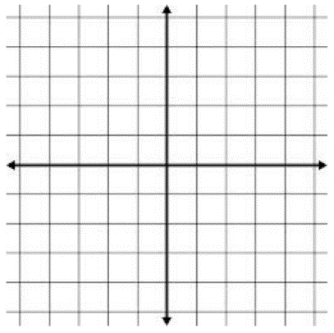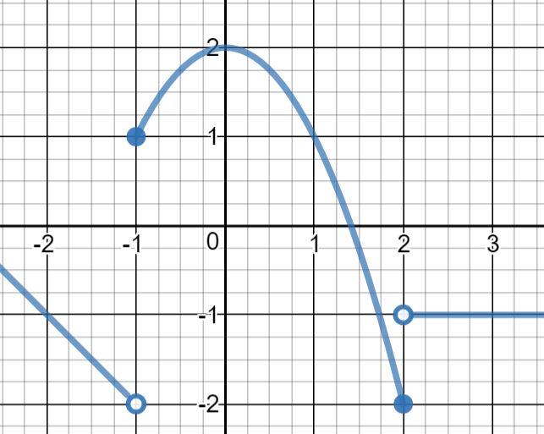



Find the zeros of the polynomial and sketch a graph

15.  16.  17. 

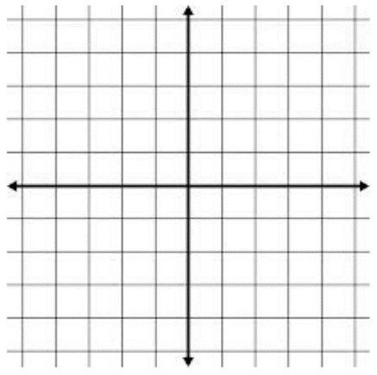



Find the all local (relative) extrema and label as a min or max. Find the intervals where the graph is increasing or decreasing.

17. **18.  (calculator)

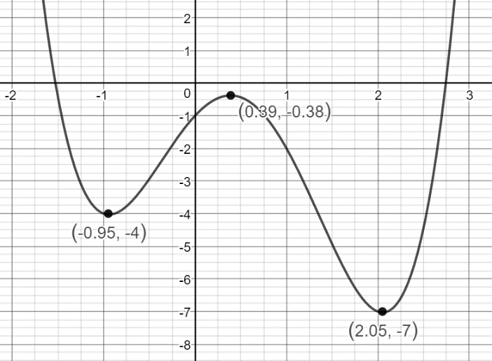

**19.  (calculator)

**Unit 8 Rational Functions and Inequalities**

Solve the inequality. Write your answer in interval notation

1.  2.  3.  4. 

For each function, find the intercepts, asymptotes, any removable discontinuities and domain

5.  6.  7.  8.  9. 

**Unit 9 Log and Exponential Functions**

Rewrite as a log or exponential function (you don’t need to solve)

1.  2.  3.  4. 

Use the laws of logs to condense

5.  6. 

Use the laws of log to expand

7.  8. 

9. True or False: 

10. Draw the exponential and logarithmic parent functions

Find the domain of the function

11.  12. 

Solve for x

13.  14.  15.  16.  17. 

18.  19.  20.  21.  22. 

23.  24.  25. 

***26. A radioactive element has a half-life of 12 days. If you start with 20 grams, how much would remain after 30 days?

***27. There are 100 bacteria present. They increase at an exponential rate. After 3 hours, there are 130 bacteria. How long will it be until there are 200 bacteria?

**Unit 10 Conic Sections**

This whole section will be on the calculator portion of the exam

1. Complete the square to find the center and radius of the circle



2. Find the equation of the ellipse shown and 3. Find the equation of an ellipse with a major axis

find the foci of 14 and foci at (-4,2) and (6,2)

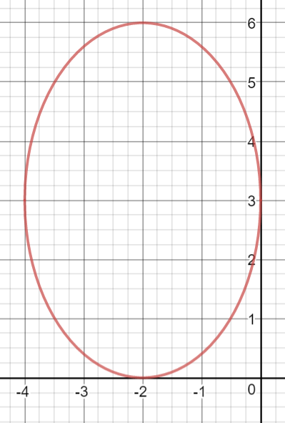

4. Find the center, vertices, foci and graph for 

5. Write the equation of an ellipse with a horizontal minor axis of 10 and vertices of (-2,-10) and (-2,12)

6. Write the equation of the hyperbola and find 7. Find the center, foci, slope of the asymptotes

the foci and graph for 

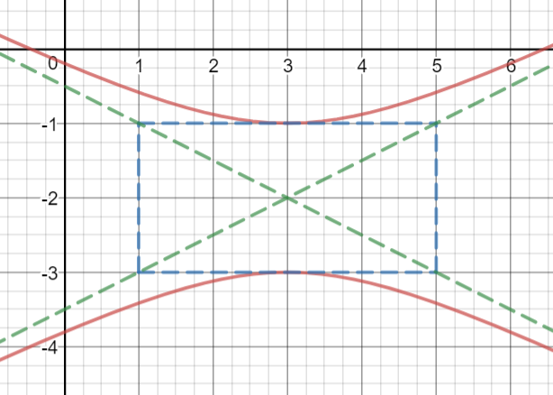

8. Write the equation of a hyperbola with vertices (-1,3) and (3,3) and co-vertices (1,7) and (1, -1).

9. Find the vertex, focus and directrix for 

10. Find the equation of a parabola with a focus of (-2,3) and a directrix of x = 8